Many battles of the Civil War were fought in South Carolina. In this lesson, you will examine statistics about the battles to learn more about the war.

Instructions: Click the links below to find information to complete each item.

Battlefields of South Carolina Map

- Where was the first Civil War battle in South Carolina? ________________

- Where was the last Civil War battle in South Carolina? ________________

- Which “Class A Decisive” battle took place in South Carolina?
________________

- How many total battles occurred in South Carolina? ________________

- Choose one of the South Carolina battles from the websites. Mark the location of the battle on the map below. Then, write a short paragraph to summarize the battle (generals, casualties, winner, etc.).
Battle: ___________________________

_________________________________

_________________________________

_________________________________

_________________________________
_________________________________

_________________________________
_________________________________

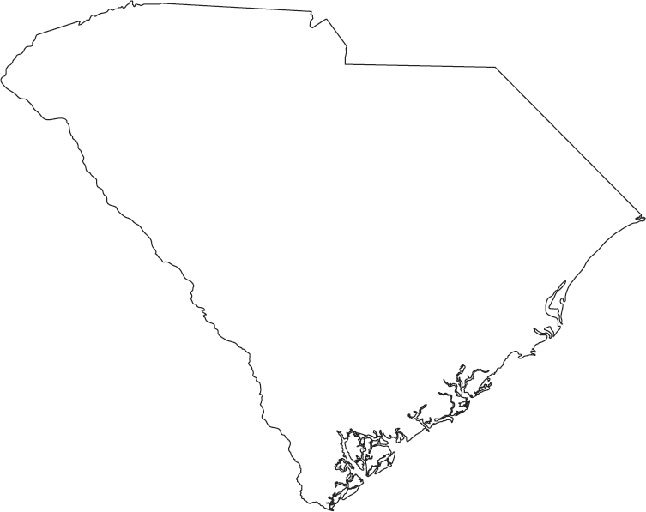

- Complete the table with information from the website. Choose four battles to study and summarize information about the battles in the table below.

Selected Battles of the Civil War in South Carolina

Battle | Date | Commanders |  | Number of Casualties |  | Winner
 |  | USA | CSA | USA | CSA
Finished Early? Check out these links to learn more about some of this lesson’s topics.
Does the Camera Ever Lie? Learn about the power of the photographer in influencing opinions of the viewers.
National Archives Civil War Photographs Photography was new during the Civil War. Check out some of these incredible photographs from the National Archives.
Harper’s Weekly Read copies of newspapers from the 1860s.

